**Computer Graphics Course Project:**

**Topic**

*Authored by*

Divyanshu Solanki 160100070

Pragun Badhan 160100114

Rohit Sencha 160100068

Tanya Gupta 150040010



Department of Mechanical Engineering  
Indian Institute of Technology Bombay

Mumbai 400076

5 November 2019

**Introduction**

The introduction chapter needs to state the objectives of the program of research, include definitions of the key concepts and variables and give a brief outline of the background and research approach. The aim of the introduction is to contextualise the proposed research.

**Work Distribution**

Pragun: Audio analyze code and relevant graphs or any other details

Rohit: Stage Modelling

Tanya: Connecting both the softwares, abstract, introduction, future scope of work

Divyanshu: Algorithm Details

**Literature Review**

The literature review chapter should demonstrate a thorough knowledge of the area and provide arguments to support the study focus. The aim of the literature review chapter is to delineate various theoretical positions and from these to develop a conceptual framework for generation of hypotheses and setting up the research question.

**Project Design**

Stage Modelling

Stage was modeled in Unreal Engine 4.23. Stage unit consists of a floor for audience, a raised stage for singer and 9 spotlights. A singer was also modelled and has basic movements like walking and jumping. The spotlights change their colour intensity based on inputs from given song.

Image represent blueprint for a blinking spotlight.

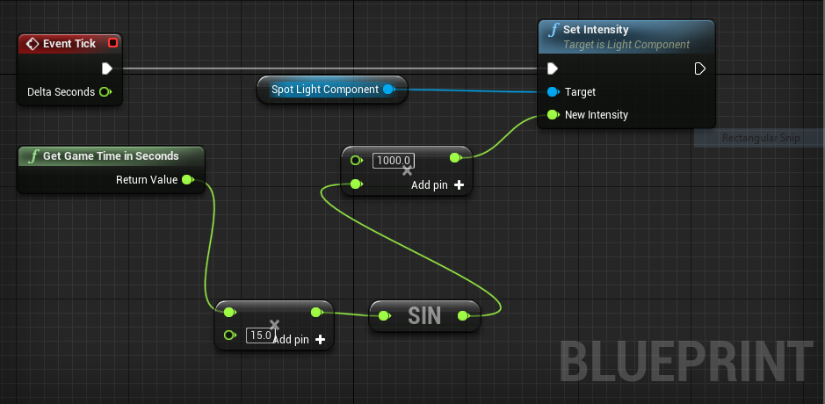

At each instant, **Event Tick** module asks **Set Intensity** module to set intensity of spotlight based on inputs to **New Intensity** value. **Get Game Time in Seconds** sends game time as input to a multiplier module. The output is then feed to sin function and then to another multiplier. Sin function enables fluctuating nature of light and multipliers alters frequency of fluctuations and boost intensity of light.

**Results**

Details all the results of your study.

**Analysis**

Chapter 5 contains a full discussion, interpretation and evaluation of the results with reference to the literature. This chapter can also include theory building

**Conclusions**

This chapter contains conclusions, limitations, and recommendations – so what is the theory? Where to from here? What are the practical implications? Discussion of where the study may be extended.

**Bibliography**

American Psychological Association (APA). (2010). *Publication Manual of the American Psychological Association* (6th Ed.). Washington, DC: Author